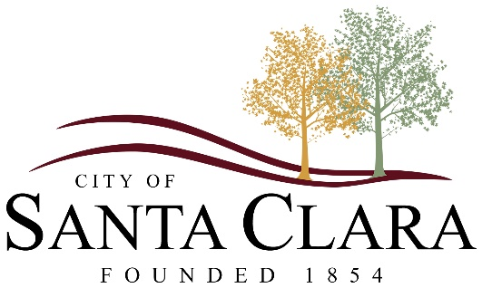
Mayor
Rick Rosenberg

City Manager
Brock Jacobsen
City Council
Denny Drake
Christa Hinton
Leina Mathis
Ben Shakespeare
Jarett Waite

Washington County Water Conservancy District Surcharge Fee

Meter Size | Rate
¾” meter | $1.75
1” meter | $3.78
1.5” meter | $12.55
2” meter | $20.20
3” meter | $45.48
4” meter | $80.85
6” meter | $181.91
*WCWCD Surcharge of $1.00 for every 1,000 gallons over 36,000 for customers that paid WCWCD impact fees before 12/31/2022
*WCWCD Surcharge of $10.00 for every 1,000 gallons based on season for customers that paid WCWCD impact fees after 12/31/2022

Increase in Excess Water Use Surcharge
Section 1. Amount of Excess Water Use Surcharge. For new connections to the District’s Regional system connecting on or after January 1, 2023 (“New Connections”), Excess Water Use Surcharge established in “A Resolution of the Washington County Water Conservancy District Board of Trustees Authorizing an Increase in the Water Development Surcharge for Excess Water Use,” adopted by the Board on December 1, 2021 (2021 Resolution), shall be increased to Ten Dollars ($10.00) per thousand gallons of potable water exceeding the thresholds set forth in Sections 2 and 3, below. (The base surcharge of the Water Development Surcharge shall remain at One Dollar and Seventy-Five Cents ($1.75) for all New Connections.)
Section 2. Residential Thresholds. The Excess Water Use Surcharge will be charged monthly for each new residential connection for which water use exceeds the monthly threshold, which varies by type of residential connection and by season, as set forth in the following table:

Residential Thresholds for New Connections
Season | Winter  (December, January,  February) | Spring  (March, April) | Summer  (May, June,  July, August,  September) | Fall  (October, November)
Potable Only Residential Connection | 8,000 gallons  per month | 15,000 gallons  per month | 20,000 gallons  per month | 15,000 gallons  per month
Potable and  Non-Potable Residential Connection | 8,000 gallons per month | 8,000 gallons per month | 8,000 gallons per month | 8,000 gallons per month

Section 3. Excess Water Use Surcharge. In addition to the base surcharge, for each issued meter, Municipal Customers will pay an “excess water use surcharge” in the amount of One Dollar ($1.00) per each thousand gallons of water used that exceeds the designated monthly demand threshold for volume of water per meter size as set forth in the following table:

Meter Size | Monthly Threshold
¾” meter | 36,000 gallons per month
1” meter | 80,000 gallons per month
1.5” meter | 260,000 gallons per month
2” meter | 420,000 gallons per month
3” meter | 850,000 gallons per month
4” meter | 1,4,000,000 gallons per month
6” meter | 2,600,000 gallons per month
8” meter | 4,200,000 gallons per month

